 |  |  | TCE Assistant
 |  |  | (ML +Firebase+ AR)
 | L.Aswin |  |  | Gowtham Balaji
M.C.A,1st year |  |  |  | M.C.A. 1nd year
 | TCE |  |  | TCE
 | Madurai, India |  |  | Madurai, India
arronissac@gmail.com |  |  |  | raiderbalaji@gmail.com
 | www.aswin.esy.es

Abstract—

We believe the future is artificial intelligence first. Artificial intelligence, is making computers "smart" so they can think on their own

- Machine learning - Teaching computers how to see patterns in data and act on it.
- Speech recognition and Language understanding - Meaning, being able to understand you when you are talking.
Apps for Assistant are an exciting new way to interact with your users through the TCE Assistant. They provide a conversational interface between you and your user, and they are super simple to build with API.AI. You can ask all type of query to Assistant apps .It is act as Good Assistant for us. It is clone app of Google assistant especially for TCE campus
Firebase is a unified mobile development platform that provides tools to help you build grow and monetize your app.
Firebase Real-time Database is a cloud-hosted NoSQL database that stores data as JSON
Cloud Functions for Firebase lets you run backend code on Google cloud infrastructure that responds to events in your Firebase project.
Finally after all result we try to use in Augmented Reality to visual in real time Motion.

ML- Machine Learning
AR-Augmented Reality

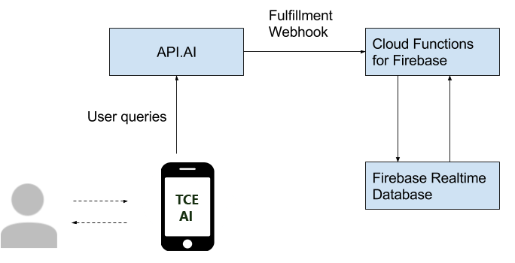

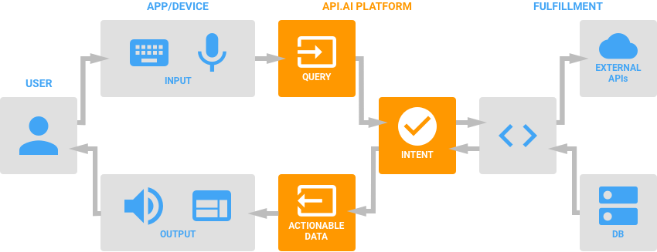

.

L.Aswin
M.C.A. 1st year
Thiyagarajar college of Enginering
Madurai, India
arronissac@gmail.com

www.aswin.esy.es
Gowtham Balaji
M.C.A. 1nd year
Thiyagarajar college of Enginering
Madurai, India
raiderbalaji@gmail.com

